Investigating Factors Affecting Airline Customer Satisfaction through Causal & Dependency Analysis

A Comprehensive Study of Passenger Data from 2022 to 2024.

By: Aarshi Jain

Email: [aarshi.jain@torontomu.ca](mailto:aarshi.jain@torontomu.ca)

Student #: 501178324

CIND820: Final Report

Supervisor: Prof. Dr. Tamer Abdou

Submission Date: June 22th, 2024

Table of Contents

Abstract 3

Introduction 5

Literature Review 7

Review 1 7

Review 2 8

Review 3 9

Review 4 9

Review 5 10

Review 6 11

Conclusion 11

Methodology 13

Dataset & Dictionary 17

Link to GitHub Repository & Dataset 17

Exploratory Data Analysis 20

Summary of Findings 21

Limitations & Ethical Considerations 29

Challenges 30

Continuity 31

Conclusion 32

References 34

# Abstract

Every year, 8.6 billion passengers fly globally, making it crucial for the airline industry to prioritize customer satisfaction as a competitive advantage (Global Passenger Traffic, n.d.). This capstone project delves into the factors influencing customer satisfaction within an undisclosed airline company, utilizing the detailed dataset titled “Airline Customer Satisfaction.” Comprising of 22 columns and 129,880 rows, this dataset provides a strong foundation for predictive analytics aimed at identifying factors of customer satisfaction from 2022 to 2024 (Huseyn, n.d.).

The primary research question guiding this investigation is: Which factors are the most pivotal in predicting customer satisfaction in the airline industry during the years 2022 to 2024? Secondary queries include examining the influence of demographic variables such as age, travel class, travel type, and customer type on satisfaction ratings. Additionally, this study investigate which aspects of airline service—such as seat comfort, in-flight entertainment, cleanliness, and food and beverage—significantly influence overall customer satisfaction. To address these questions, the dataset offers comprehensive insights into customer experiences, including customer type, age, purpose of travel, and travel class. It also provides specific ratings for services like seat comfort, gate location convenience, departure/arrival time, and baggage handling. This information-rich dataset allows for a multifaceted analysis of customer satisfaction factors.

The analytical techniques utilized in this investigation encompass classification and regression models, clustering, and text mining. Classification algorithms such as decision trees and logistic regression predict customer satisfaction levels based on characteristics and travel experiences (Logistic Regression, n.d.). Clustering techniques, like K-means, identify different groups of customers with specific determinants contributing to their satisfaction (Webster, n.d.). Text mining of feedback provides qualitative insights into customer sentiments (Text Mining, n.d.). Model evaluation metrics such as precision, accuracy, and F1-score assess the performance and effectiveness of the statistical and machine learning models (Srivastava, 2024). Tools such as R and Python, along with specialized libraries like Scikit-Learn and the “tm” package in R, are employed for data analysis and model building (Choudhary, 2022). This research aims to build upon and potentially replicate findings from previous studies using similar datasets, with the goal of providing a detailed analysis of the factors affecting customer satisfaction regarding airlines. This research follows the same techniques used in multiple studies, often combining methods for a deeper analysis, such as the Apriori Algorithm and Logistic Regression. Any differences in research methodology or tools will be highlighted, ensuring clarity on how this study adds to existing knowledge.

By investigating this dataset, airlines can gather critical insights into the determinants of customer satisfaction, enabling them to tailor services effectively and enhance the overall customer experience. This research will provide proactive insights for airline companies seeking to strengthen customer loyalty and improve service quality, thereby gaining a competitive edge in the market.

# Introduction

The airline industry was one of the largest industries to suffer the most from the global pandemic, COVID-19, which began in March 2019. Due to the numerous lockdowns, passenger numbers and revenue dwindled while high fixed costs remained, resulting in financial losses. It was found that “a number of airlines around the world had to file for bankruptcy, while others were kept on financial life support from governments, leading to major layoffs for employees” (Mordvinova, 2022). Ever since the COVID-19 travel restrictions were lifted in 2022, airline companies have been struggling with numerous challenges they were unprepared for such as staffing shortages, a sudden increase in passenger traffic, and the Russian-Ukraine war causing airlines to reroute flights and face fuel availability uncertainty due to this conflict (Singh, 2024).

Another challenge for airline companies is the increase in unruliness from customers due to chaos caused in airports. Since 2021-2022, there has been a 47% increase in customer non-compliance (Sternfield, 2023). The aggravated customers stem from the fact that, compared to 2021, the 2022 mishandling rate of 7.6 bags per thousand passengers represents a 75% increase (*Baggage Mishandling Rates*, 2023). Flight irregularities, mishandled baggage, and long waiting times form the core of passenger dissatisfaction (Mehra, 2023). About 34.4% of aircraft arrived late in 2022 and 37.0% in 2023, with nearly half of the delays being the airlines’ fault since late flights cause a chain reaction leading to more late flights (Thygerson, 2023; Major, 2023). Airfares spiked by 25% compared to 2022, causing more chaos for airlines and creating fussy customers demanding better quality (Holzhauer, 2024).

An estimated 4.7 billion people will be flying in 2024 surpassing the previous record set in 2019, indicating a simultaneous increase in travel demands (Cousins, 2023). It is crucial for airline companies to gain information on how to satisfy customers and understand the needs and expectations of customers flying. To achieve this, aviation companies must investigate passenger satisfaction to identify which aspects of their experience require improvement. The increasing demand for air travel will lead to intense competition in the industry, which is why airline companies must offer high-quality service to exceed customer expectations.

This project report utilizes the Airline Customer Satisfaction dataset, which contains ratings from 1-5 (with 5 being the most satisfied) reflecting passengers’ experiences with the airline along with some general information about the travellers such as their age, class and type of travel. The data was collected from passengers of a major international airline operating across multiple regions, primarily focusing on North America and Europe, from 2022 to 2024. The aim of the report is to identify the most influential predictors of passenger satisfaction using both supervised and unsupervised machine learning techniques. The goal is to help airline companies gain a deeper understanding of how their services impact customer satisfaction and determine which services and passenger types they should invest in to grow and retain loyal customers. Furthermore, the report assesses the efficacy of the models used in the analysis.

# Literature Review

In the aftermath of the global pandemic, aviation companies are facing challenges in accommodating a growing population of air travelers while striving to maintain high levels of customer satisfaction. Understanding how to meet these needs and exceed airline expectations is crucial for airlines to thrive in the competitive aviation industry. This study reviews previous research to explore machine learning techniques that have been utilized to identify the key factors essential for enhancing customer satisfaction and driving business development in aviation companies.

First review:

In Tri Noviantoro and Jen-Peng Huang’s study, they employed data mining techniques to investigate airline customer satisfaction. Initially, they prepared the data by filtering and eliminating entries with missing values. Their study utilized the wrapper method for feature selection, employing forward selection. Using a 10-fold cross-validation strategy to split the data into training and testing sets, the researchers identified "Online Boarding" as the highest-ranked attribute across all validation processes for feature selection. Following feature selection, they retrained the model using the top five selected features and applied eight supervised machine learning algorithms, including decision tree, random forest, gradient boosted tree, k-NN, Naïve Bayes, rule induction, logistic regression, neural net, deep learning, and support vector machine. Model evaluation was conducted using a confusion matrix, revealing that Deep Learning achieved the highest accuracy at 92.08% and the highest F-score at 93.03% in predicting airline passenger satisfaction. Additionally, k-NN demonstrated an accuracy of 91.07% and an F-score of 92.38%. Overall, their study identified the top four factors most crucial for customer satisfaction as: (1) online boarding, (2) inflight Wi-Fi service, (3) baggage handling, and (4) inflight entertainment (Noviantoro & Huang, 2022).

This study’s methodology will be adapted, especially the feature selection and cross-validation techniques. The research question: “What are key predictors of customer satisfaction in the airline industry?” will be answered using tools such as forward selection and supervised learning algorithms.

Second Review:

Yifei Wang conducted a comprehensive study on the factors influencing airline customer satisfaction employing structured data mining techniques. The research integrates exploratory data analysis (EDA) and statistical methods, emphasizing the impact of demographic characteristics and service-related factors. Dimensionality reduction techniques were applied to streamline the dataset and enhance model performance, with Principal Component Analysis (PCA) used to reduce feature complexity while retaining data variance. The primary objective was to aid airline companies in optimizing customer satisfaction by identifying key influencing factors. First, Wang conducted EDA to uncover patterns, anomalies, and address missing values by imputing them with the variable averages. Subsequently, a Factor Analysis was performed using Bartlett’s sphericity test, demonstrating significant correlations (P < 0.05) among variables and validating the suitability of factor analysis. Two principal factors emerged: "Fundamental Items," encompassing cleanliness, food and drink, seat comfort, and in-flight entertainment; and "Basic Service," including in-flight service, baggage handling, onboard service, and legroom. Further analysis involved one-way ANOVA to compare satisfaction levels across different demographic groups. Wang also employed Logistic Regression using the factors derived from dimensionality reduction (Wang, 2023). Overall, the study concluded that reducing delays and enhancing the travel class experience are critical steps toward improving customer satisfaction in the airline industry.

This study’s methodology will be adapted, especially the application of Exploratory Data Analysis (EDA) and Principal Component Analysis (PCA) which will be used to refine the data. This method will help answer the research question: “How does demographic factors influence customer satisfaction?” as it will provide insight on the demographic impacts on satisfaction.

Third Review:

Sachin Kumar and Mikhail Zymbler utilized sentiment analysis of tweets to assess customer satisfaction in their study. The primary classification models employed included Support Vector Machines (SVM), Artificial Neural Networks (ANNs), and Convolutional Neural Networks (CNN). Additionally, they conducted Association Analysis using the Apriori algorithm to extract frequent item-sets and generate association rules for both positive and negative sentiment categories. This approach revealed insights into how travel-related issues impact customer sentiments during flights (Kumar & Zymbler, 2019).

Sentiment analysis and Association analysis techniques will be employed to provide qualitative information and underlying relationships within the dataset which will address the secondary research question: “Which aspects of airline service influence customer satisfaction?”

Fourth review:

Xuchu Jiang, Ying Zhang, Ying Li, and Biao Zhang conducted a study focusing on predicting aircraft passenger satisfaction using an RF-RFE-LR (RanFdom Forest-Recursive Feature Elimination-Logistic Regression) model. Initially, they employed a Random Forest algorithm with cross-validation to rank feature importance. Subsequently, Recursive Feature Elimination was utilized to select the top 17 features from an initial set of 22. Several machine learning models, including K-Nearest Neighbors, Logistic Regression, Random Forest, Gaussian Naive Bayes, and Backpropagation Neural Network (BNN), were applied to predict satisfaction using both RFE and non-RFE methods. To evaluate the classification models, the study employed accuracy, recall, precision, F-value, and AUC as evaluation metrics across ten models (five with RFE and five without RFE). The findings underscored that feature selection notably enhanced model performance, with the Random Forest-RFE classifier achieving the highest accuracy of 0.963. Additionally, logistic regression was performed to identify the top predictors for customer satisfaction in airlines, highlighting "Type of Travel," "Customer Type," "Customer Class," "In-flight Wi-Fi Service," and "Online Boarding" as the most influential variables based on their coefficient values (Jiang et al., 2022).

To enhance the model performance, the RF-RFE-LR model as well as cross-validation technique will be utilized to identify the top determinants for customer satisfaction.

Fifth Review:

Chris Bacani conducted research on airline customer satisfaction utilizing Scikit-Learn's K-Best and Chi-Square functions for feature selection. The study began with data cleaning and preparation, including handling null values in Arrival delays, text normalization, aggregating flight delay data, and scaling features. Feature selection techniques K-Best and Chi-Square were applied to identify and extract the 15 most significant features. Subsequently, Bacani trained multiple classifiers including Logistic Regression, Adaptive Boosting, Random Forest, Categorical Naive Bayes, and Extreme Gradient Boosting using the selected features. Model performance was evaluated based on training and test accuracy, precision, recall, and ROC values. The study also included an analysis of model metrics, confusion matrices depicting classification performance, and ROC AUC curves. Among the classifiers tested, the Extreme Gradient Boosting classifier demonstrated the highest accuracy of 95% and 94.6%. Bacani further utilized Python's pickle library to serialize the model, enabling analysis of feature impacts using SHAP (Bacani, 2022).

For feature selection, Scikit-Learn’s K-Best and Chi-Square functions will be employed. As done in this study, multiple classifiers such as Logistic Regression, Random Forest, and Extreme Gradient Boosting will be trained.

Sixth Review:

Sangah (Ivy) Kim's study investigates airline customer satisfaction using exploratory data analysis (EDA) and multiple machine learning algorithms. The research begins with thorough data preparation, including imputing missing values with medians for normalization, removing redundant columns, and creating dummy variables for categorical data. Initially, logistic regression with all features identifies the most important variables. Kim then explores interactions between features through additional logistic regression to understand their relationships. To address collinearity, lasso feature selection refines the feature set, identifying significant predictors such as in-flight Wi-Fi and boarding procedures. Classification trees are employed to extract interpretable rules, highlighting factors like online boarding scores and travel type (business vs. personal) that strongly influence satisfaction. A Random Forest model validates the importance of identified features by outperforming the decision tree, leveraging the random selection of predictors during model training. Kim further validates model performance through cross-validation, revealing consistent accuracy across most models, with the exception of the decision tree, which performed less optimally (Kim, 2023).

From this methodology, Lasso Regression and Random Forest will be employed for model validation as well as for feature selection. This approach will help in understanding feature interactions and will ensure the robustness of the model.

Conclusion

In reviewing the research reports, it becomes evident that Random Forest consistently demonstrated superior performance across different datasets, with the exception found in Chris Bacani’s research where Extreme Gradient Boosting excelled. Among the studies, "In-Flight Wi-Fi Service" emerged as a consistently influential factor for predicting airline customer satisfaction.

Furthermore, a common practice among researchers was the use of feature selection techniques to reduce dimensionality before applying machine learning models. They then utilized feature importance to identify the most influential predictors after evaluating the models. This approach mirrors methodologies employed by Xuchu Jiang, Ying Zhang, Ying Li, Biao Zhang, Chris Bacani, Tri Noviantoro, and Jen-Peng Huang.

This study intends to integrate these methodologies, drawing particularly from the approaches of Xuchu Jiang et al., Chris Bacani, and Sachin Kumar and Mikhail Zymbler. It will also incorporate techniques such as Association rules and the Apriori algorithm, as explored by Kumar and Zymbler, to uncover relationships and patterns within categorical data.

# Methodology

The following steps outline a tentative, structured methodology for analyzing airline customer satisfaction:

1. Data Collection and Preprocessing

* **Data Cleaning**: Handle missing values.
* Identify and handle all the missing values by replacing them with the mean/median values or removing the row/column. This step was done in all the studies, such as Noviantoro and Huang’s study, where data preparation involved replacing missing values with the medians of the feature and removing columns that are not necessary for the research. This ensures the data is clean for accurate model training which impacts the reliability of the predictions (Noviantoro & Huang, 2022).
* **Data Transformation:** Convert categorical variables into numerical values.
* As used in Tri Noviantoro and Jen-Peng Huang's research, this study will use one-hot encoding for categorical variables such as ‘Satisfaction’, 'Customer Type', 'Type of Travel', and 'Class' for model compatibility (Noviantoro & Huang, 2022).
* **Normalization/Standardization:**
* Normalizing data makes sure that all features are scaled to be comparable (Bacani, 2022). The standardized data improves model training efficiency and accuracy. This will be done using the Python package “ydata profiling” and “SweetViz”.

2. Exploratory Data Analysis (EDA)

* **Descriptive Statistics**: Summarize the data to gain insights into its basic features and data distribution.
* Sangah Kim used EDA to develop an understanding of the dataset (Kim, 2023). This helps to learn about variances, outliers, the spread of data, and central tendencies which is vital for informed model selection and feature engineering. This will be done through the use of visual tools such as histograms, box plots, and scatter plots to identify patterns and outliers with the help of Python packages like “ydata profiling” and “SweetViz”.
* **Correlation Analysis**: Using a correlation matrix to identify relationships between features.
* By generating a correlation matrix, the study will identify relationships between features. Correlation analysis was performed by Chris Bacani to find key determinants impacting customer satisfaction (Bacani, 2022). The correlation matrix will help select features likely to be significant predictors of customer satisfaction.

3. Feature Selection

* **Recursive Feature Elimination (RFE)**: As used by Xuchu Jiang et al, this study will implement RFE with a Random Forest model to select the most important features by iteratively removing the least significant features (Jiang et al., 2022). RFE helps by reducing dimensionality.
* **K-Best or Chi-Square:** To identify significant features, apple feature selection techniques.
* Initial feature selection was found using K-Best and Chi-Square techniques (Bacani, 2022). This method reduces dimensionality and emphasizes the most important determinants which enhance the model’s performance and interpretability.
* **Lasso Regression:** Refine the feature set by using Lasso Regression.
* To remove collinearity, Sangah Kim used Lasso Regression to increase the robustness of the model (Kim, 2023).

4. Model Building and Evaluation

* **Train-Test Split**: Split the dataset into training and testing sets (20/80).
* **Train Models**: Train machine learning models, including:
  + **Decision Trees**: To understand feature interactions as well as interpretability (Noviantoro & Huang, 2022).
  + **Random Forest**: For its performance and ability to handle large datasets with high-dimensional features. Random Forest was consistently found to be one of the most effective learning models as stated by numerous researchers such as Xuchu Jiang (Jiang et al., 2022).
  + **Logistic Regression**: To provide interpretable coefficients and identify key predictors (Noviantoro & Huang, 2022).
* These models are key to predicting customer satisfaction levels based on a variety of features, directly addressing the primary research question of which factors are the most important in predicting customer service satisfaction.
* **Association Analysis (Apriori Algorithm):** To discover relationships between categorical variables. Sachin Kumar and Mikhail Zymbler’s study was the only one which used Sentiment, and Association analysis to find patterns between the variables (Kumar & Zymbler, 2019). This algorithm will answer the secondary questions pertaining to demographic variables corresponding to high and low customer rating values.  These techniques will be included to provide qualitative information and find underlying relationships within the dataset. It address the secondary research question: “Which aspects of airline service significantly influence customer satisfaction?”
* **Model Evaluation**: Evaluate models using metrics such as accuracy, precision, recall, F1-score, and ROC-AUC to assess performance and effectiveness. This ensures that the models are accurate and reliable which will validate the results of the predictions.

5. Cross-Validation

* **Cross-Validation:** Used by numerous researchers such as Noviantoro and Huang, and Xuchu Jiang, cross-validation provides confidence that the model will perform well on unseen data, preventing overfitting and making sure all predictions and satisfactory (Noviantoro & Huang, 2022; Jiang et al., 2022).

7. Reporting and Documentation

* **Report Findings**: Document the methodology, analysis, and results in a comprehensive report.
* **Recommendations**: Provide actionable recommendations based on the analysis to help improve airline customer satisfaction.

# Dataset and Dictionary

This study uses the open-source dataset “Airline Customer Satisfaction” available on the Kaggle website. It contains 22 features and 129,880 rows of data.

**Links**

GitHub Link:

<https://github.com/justatoj/CIND820-.git>

Dataset Link:

<https://www.kaggle.com/datasets/raminhuseyn/airline-customer-satisfaction/data>

Data dictionary:

|  |  |
| --- | --- |
| Feature | Description |
| Satisfaction | Indicates the satisfaction level of the customer. |
| Customer Type | Type of customer ('Loyal’ or 'Disloyal’). |
| Age | Age of the customer. |
| Travel Type | Purpose of the travel ('Business' or 'Personal’). |
| Class | Class of travel ('Business', 'Eco', or 'Eco Plus’). |
| Flight Distance | The distance of the flight (in kilometres). |
| Seat comfort | Rating of seat comfort provided during the flight (1 to 5). |
| Departure/Arrival time convenient | Rating of the convenience of departure/arrival time (1 to 5). |
| Food and Drink | Rating of food and drink quality provided during the flight (1 to 5). |
| Gate location | Rating of gate location convenience (1 to 5). |
| Inflight wifi service | Rating of inflight wifi service satisfaction (1 to 5). |
| Inflight entertainment | Rating of inflight entertainment satisfaction (1 to 5). |
| Online support | Rating of online customer support satisfaction (1 to 5). |
| Ease of Online booking | Rating of ease of online booking satisfaction (1 to 5). |
| On-board service | Rating of on-board service satisfaction (1 to 5). |
| Legroom service | Rating of leg room service satisfaction (1 to 5). |
| Baggage handling | Rating of baggage handling satisfaction (1 to 5). |
| Check-in service | Rating of check-in service satisfaction (1 to 5). |
| Cleanliness | Rating of cleanliness satisfaction (1 to 5). |
| Online boarding | Rating of online boarding satisfaction (1 to 5). |
| Departure Delay in Minutes | Total departure delay in minutes. |
| Arrival Delay in Minutes | Total arrival delay in minutes. |

# Exploratory Data Analysis (EDA)

In the EDA conducted as documented in the repository, comprehensive data cleaning methods were employed, including the reduction of null values, construction of correlation matrices, comparison of categorical and numerical values, and generation of histograms for all numerical features, among other techniques. These steps were crucial in gaining insights into data distributions, identifying patterns, and preparing the dataset for further analysis. For a detailed overview of the EDA procedures followed, please refer to the repository documentation.

# Summary of Findings

**1.0 Introduction**

The primary objective of this study was to identify key predictors of customer satisfaction and analyze the influence of demographic and service-related variables. The dataset is comprised of 22 column and 129,880 rows, providing comprehensive insights into customer experiences.

**2.0 Data Cleaning and Pre-Processing**

First, data cleaning and pre-processing techniques such as the replacement of null values, data transformation, normalization, One-hot Encoding and converting the target variable, “Satisfaction”, was necessary to ensure the dataset remains robust. This is required to handle outliers and anomalies within the dataset which cause the dataset to be unreliable and unworkable. The following snippets of code showcase some of the data cleaning processing techniques involved.

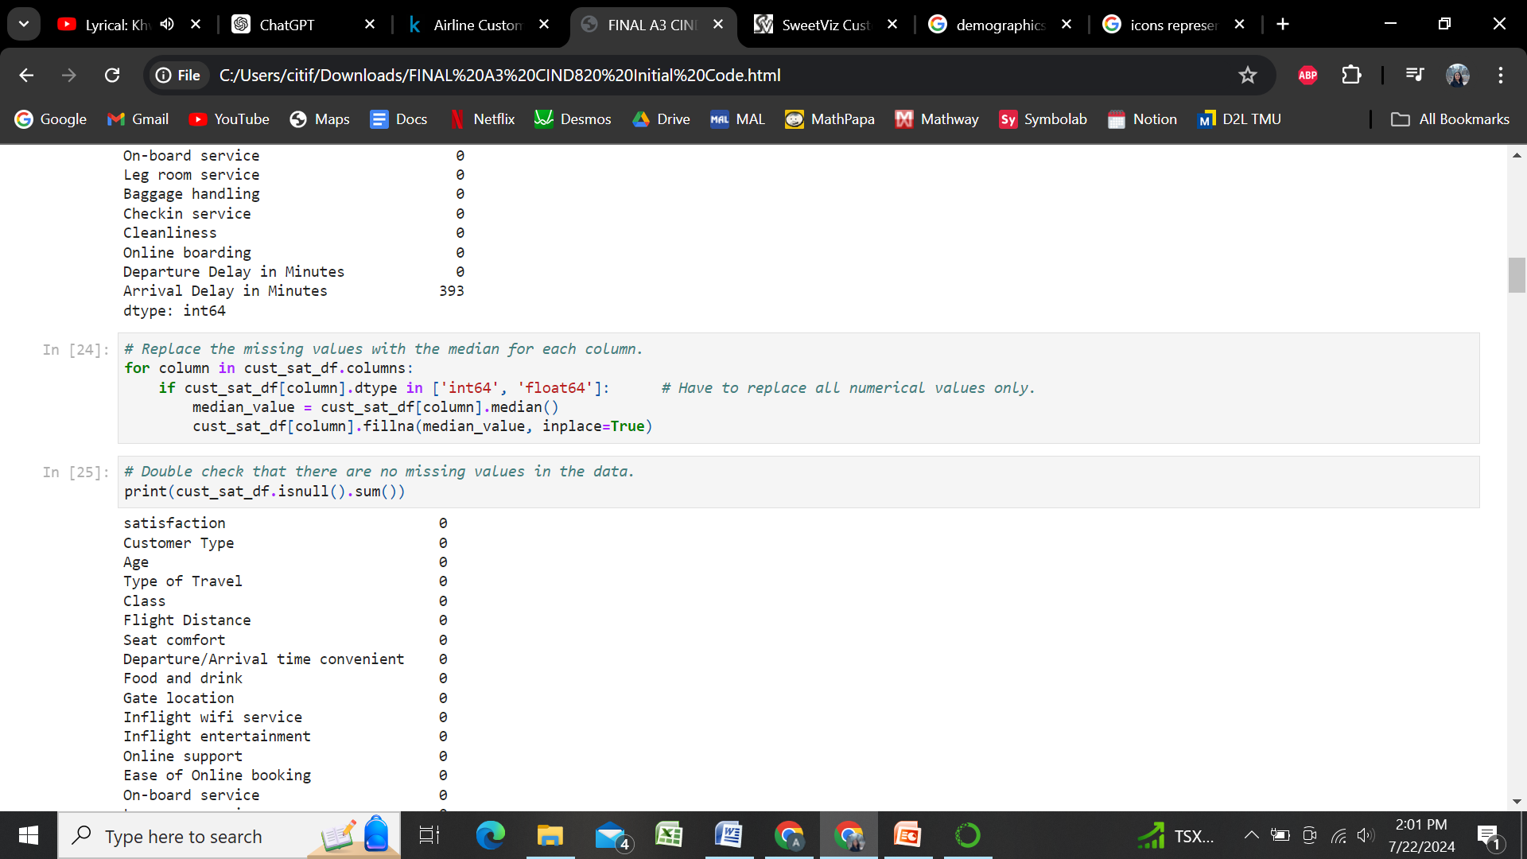

**Figure 1.** Replace all null values with the median of the corresponding column.

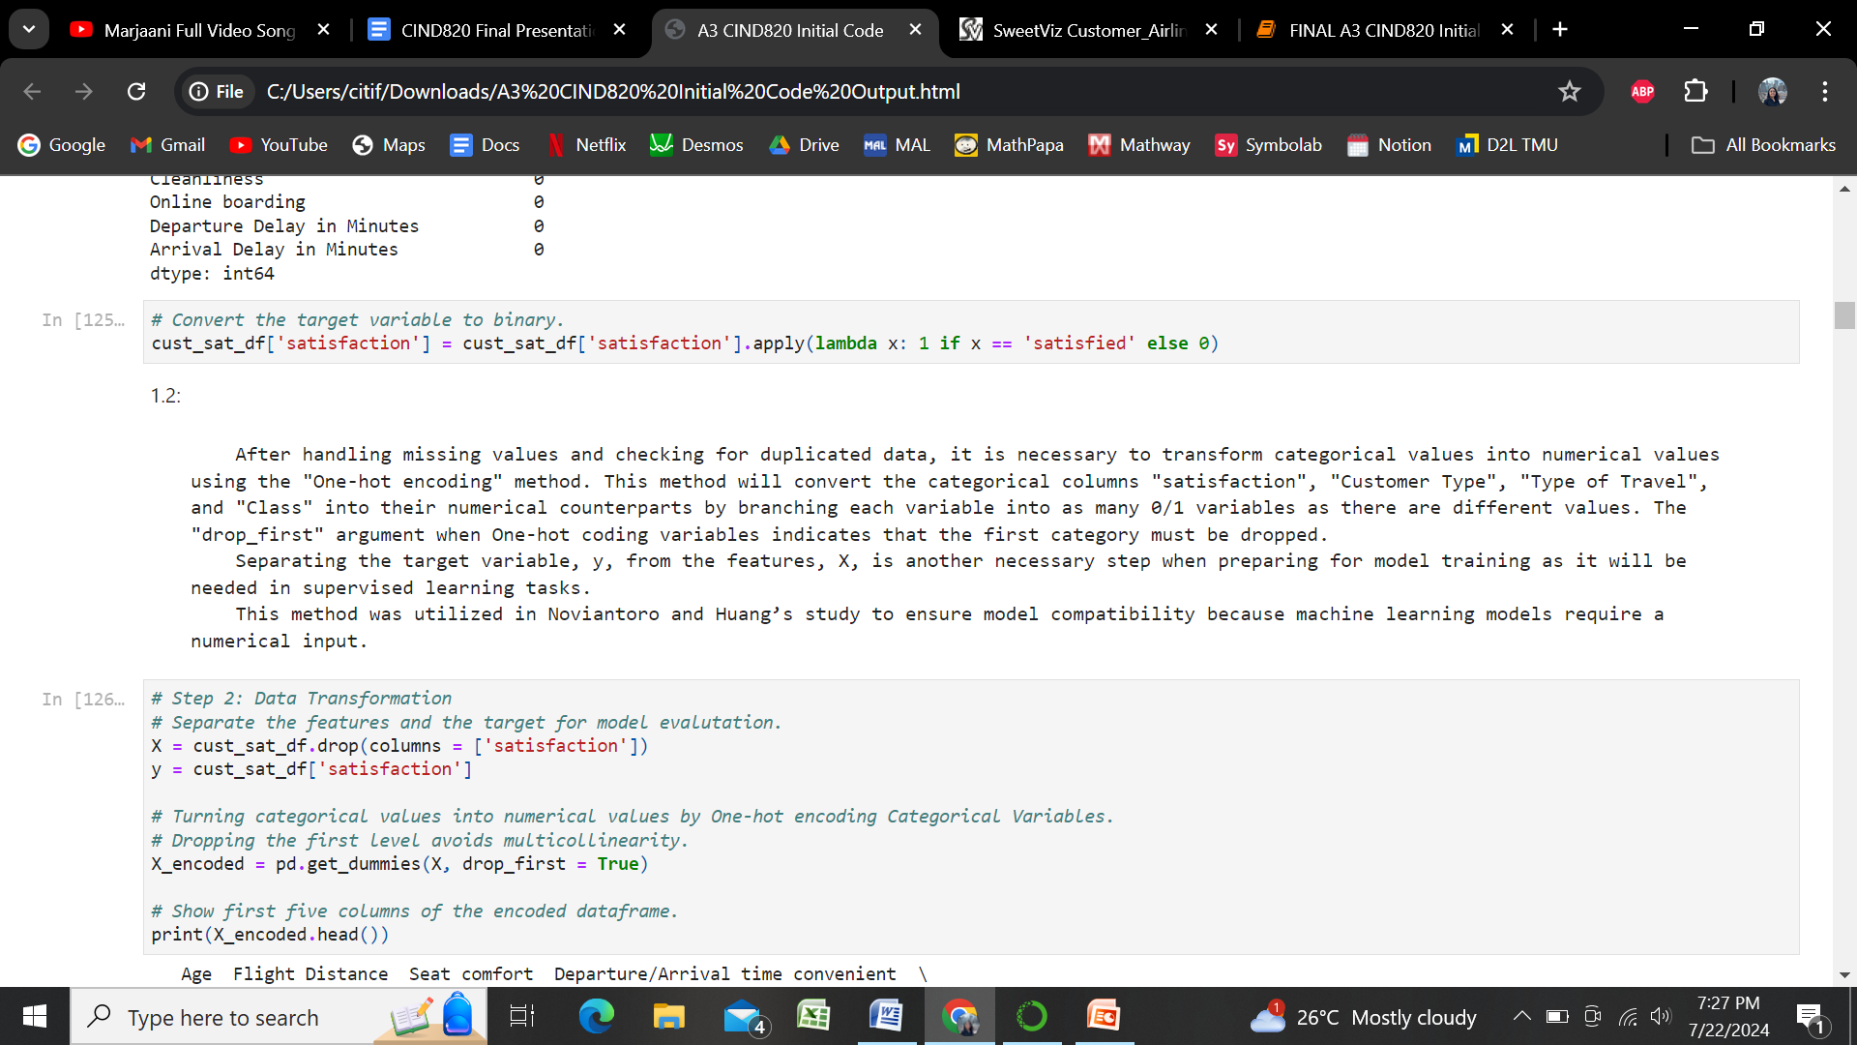

**Figure 2.** Use the One-hot encoding technique to transform categorical values into numerical.

**3.0 Exploratory Data Analysis (EDA)**

Next, Exploratory Data Analysis (EDA) was employed with the help of Pandas, and “SweetViz”, ; a python library which generates detailed reports about the dataframe being used. An EDA Report is vital for well-informed decision making in feature selection and model construction because it offers an understanding of the data distribution, spot anomalies, and identify important patterns. For instance, visual tools like histograms and box plots are used to summarize data.

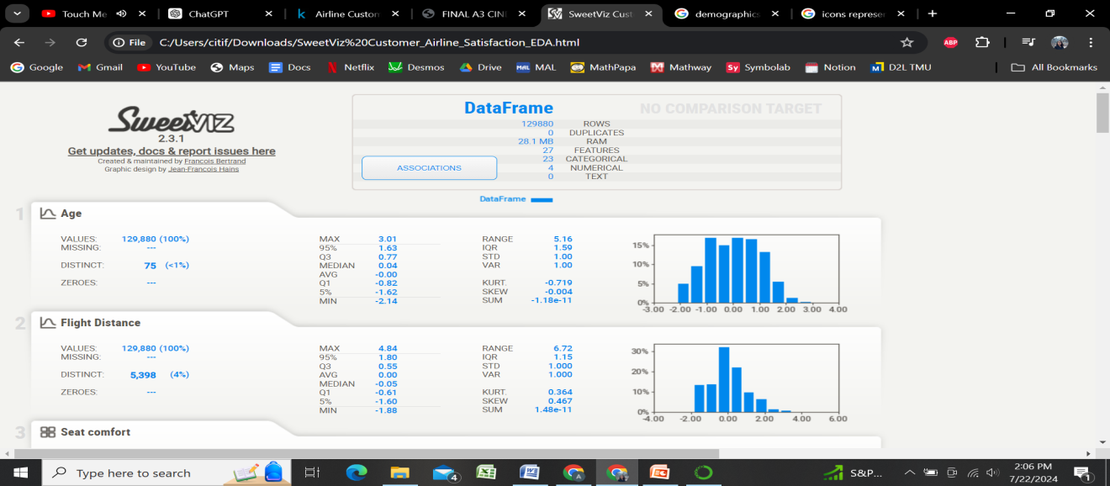

**Figure 3.** Exploratory Data Analysis Report (EDA) of the dataset.

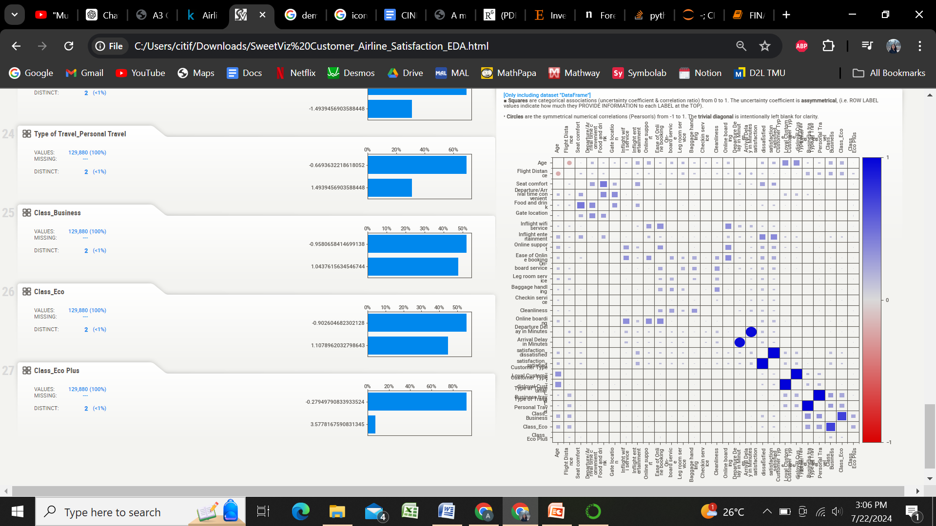

**Figure 4.** Association matrix regarding the correlation between features.

From the Correlation Matrix generated by SweetViz's EDA report, some of the results found are:

1. Class_Business and Type of Travel_Business travel: A strong positive correlation indicating that customers travelling for business often travel in business class.

2. Flight_Distance and Age: A strong negative correlation indication that the older the customer, the less likely they are to fly long distances.

3. Food_And_Drink and Seat_Comfort: A very strong positive correlation indication that better quality refreshments lead to higher seat-comfort ratings.

**4.0 Feature Selection with Recursive Feature Elimination (RFE)**

Feature selection was performed using techniques such as Recursive Feature Elimination (RFE) and K-Best instead of techniques like Lasso or Chi-Square due to their efficiency and simplicity.

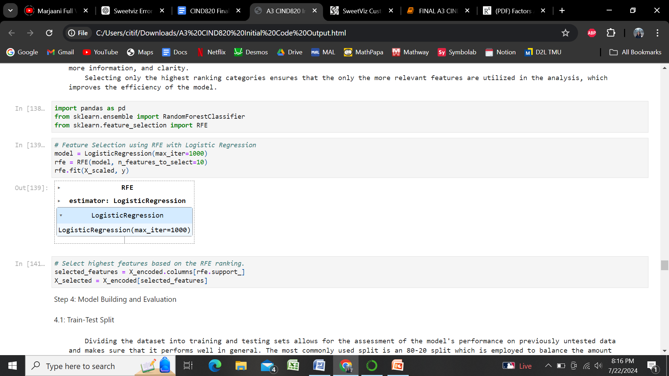

**Figure 5.** Feature selection using Recursive Feature Elimination (RFE) and selecting the highest RFE ranking features.

**5.1 Model Building and Evaluation**

Several machine learning models were trained including Decision Trees, Random Forest, and Logistic Regression. These models were evaluated using various metrics such as accuracy, precision, recall, F1-Score, and ROC-AUC to assess their effectiveness and performance.

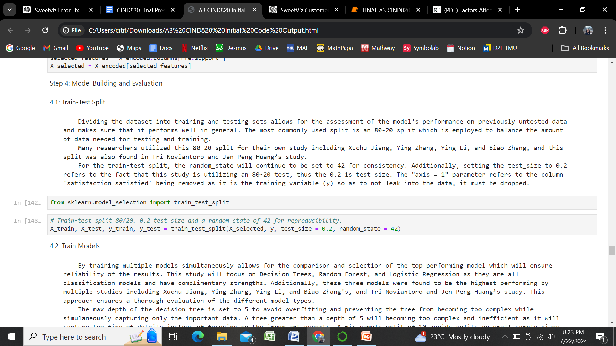

**Figure 6.** Setting up train-test split of 80/20 with a random state of 42 for reproducibility.

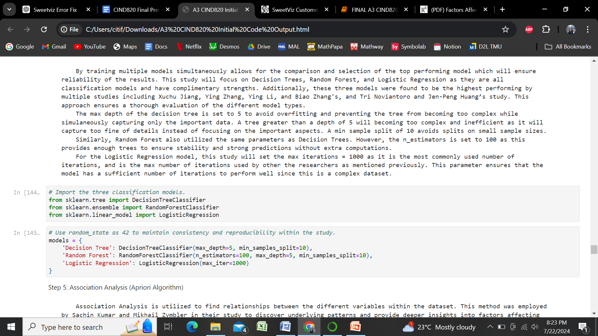

**Figure 7.** Training the three classification models; Decision Tree, Logistic Regression and Random Forest.

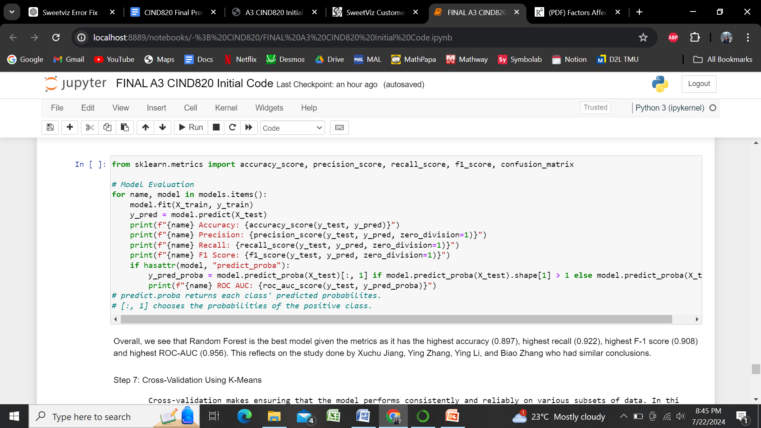

**Figure 8.** Model Evaluation using the metrics “Accuracy”, “Precision”, “Recall”, “F1-Score”, and the “ROC-AUC” curve.

Overall, this model evaluation found that Random Forest is the best model given that is has the highest accuracy (0.897), highest recall (0.922), highest F-1 score (0.908) and highest ROC-AUC (0.956). This reflects on the study done by Xuchu Jiang, Ying Zhang, Ying Li, and Biao Zhang who had similar conclusions.

**5.2 Apriori Algorithm**

The Apriori Algorithm was used to find hidden patterns and underlying relationships within the dataset.

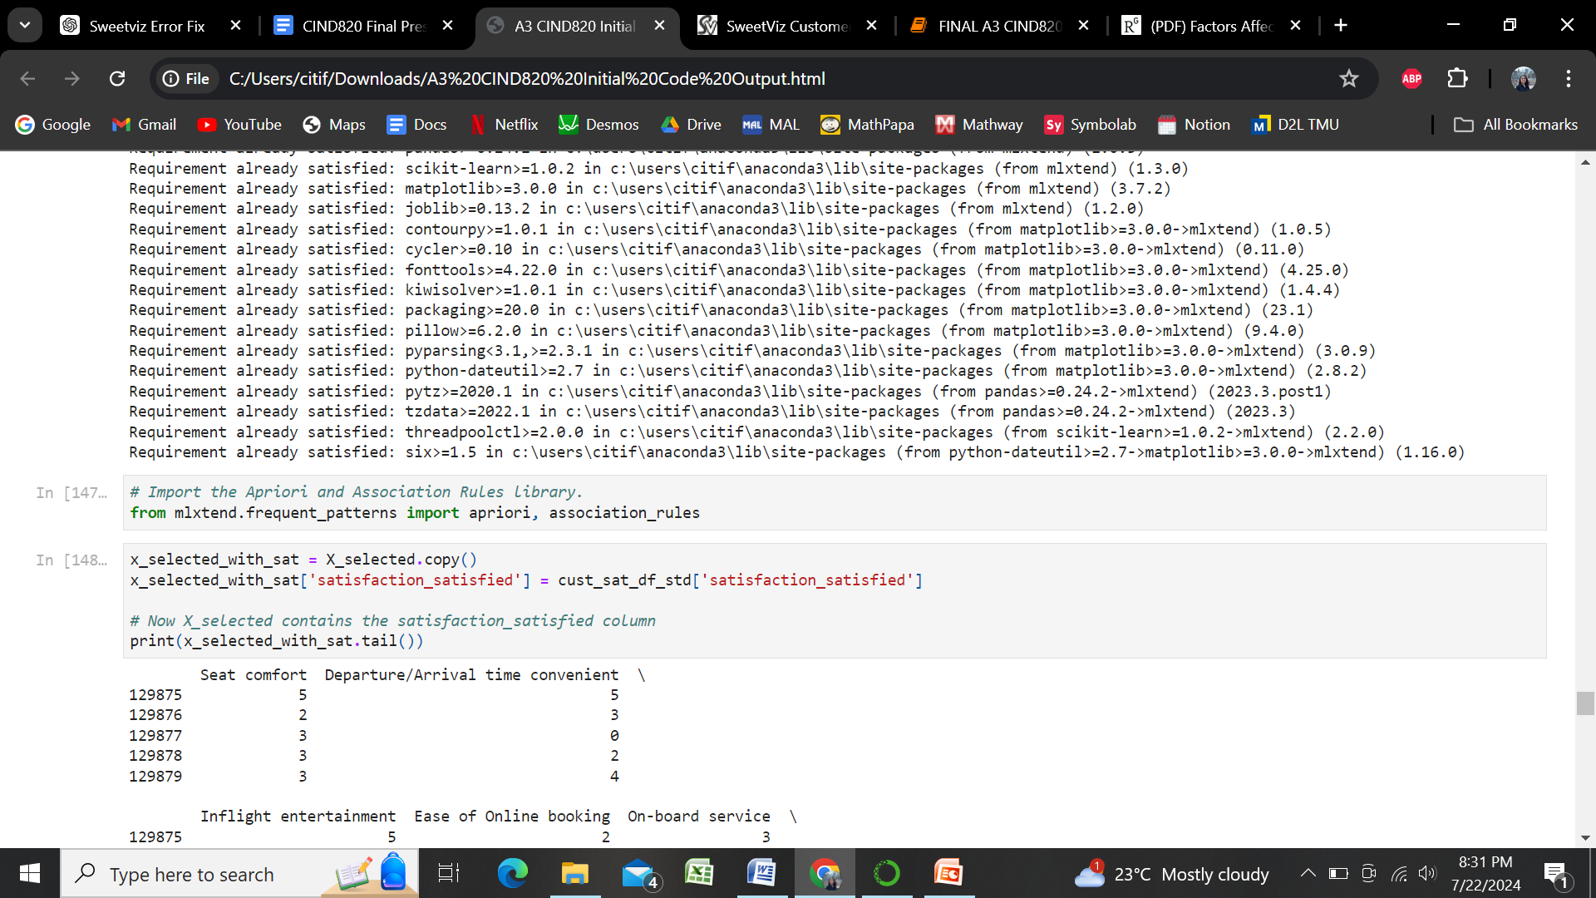

**Figure 9:** Selecting the “Satisfied” feature and finding the associations correlating with airline customer satisfaction.

**7.1 Cross-Validation**

Cross-validation was implemented to ensure the robustness and generalizability of the models. This study chose 10-fold cross-validation to provide a thorough assessment of model performance by training and testing the model on multiple data splits. This method helps prevent overfitting and ensures that the models perform well on unseen data.

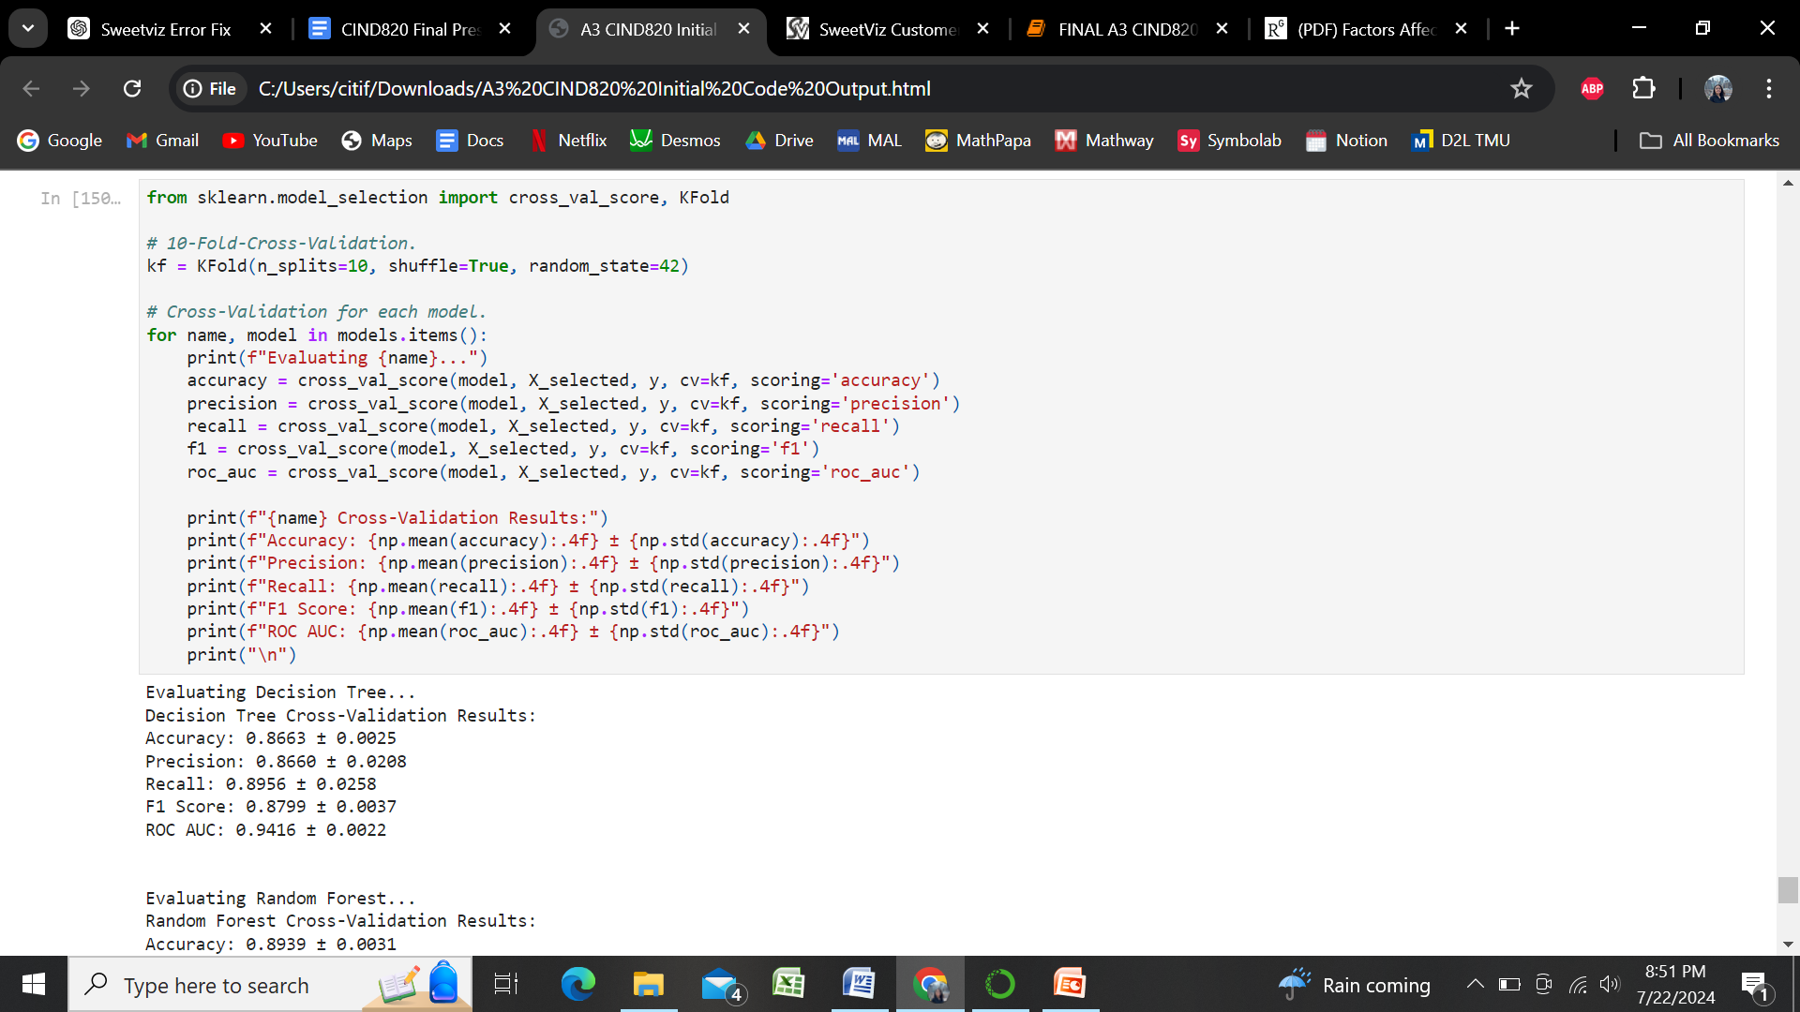

**Figure 10:** 10-Fold-Cross-validation of the three classification models as well as the head of the outputs to verify the ranks of Accuracy, Precision, Recall, F1-Score, and ROC-AUC of each classification model.

**7.2 Feature Importance Graph**

Then, a feature importance graph is created to show the top three highest ranking determinants in predicting customer airline satisfaction.

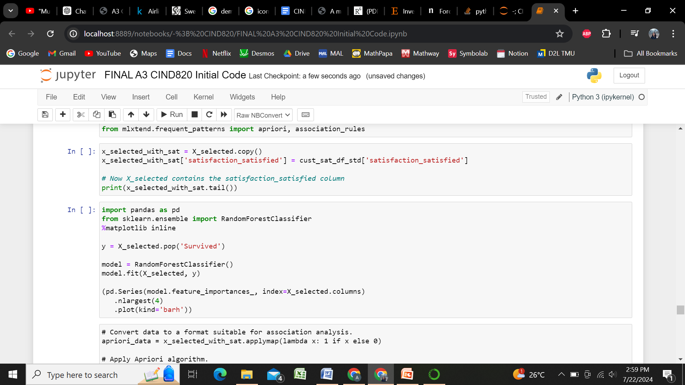

**Figure 11:** Determining the top three highest factors in predicting airline customer satisfaction.  
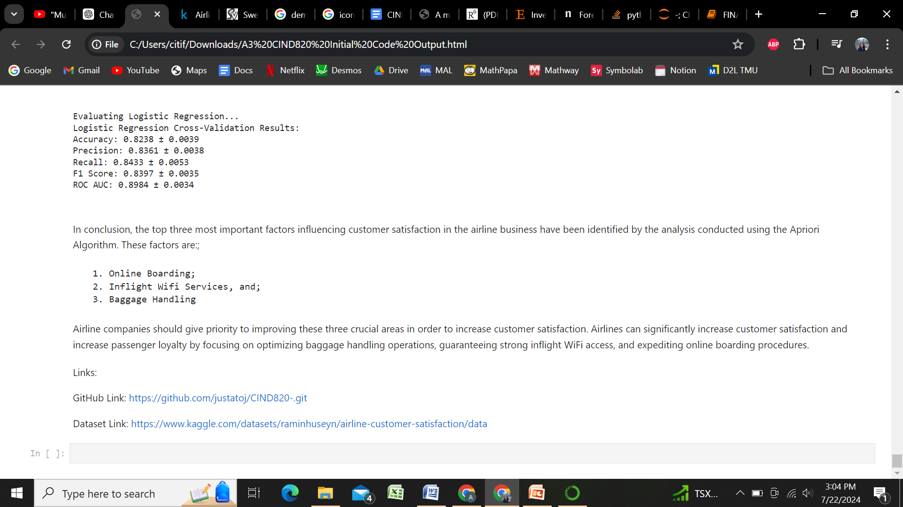

**Figure 12:** Output of **Figure 9**, stating the top three factors.

Overall, the analysis revealed that inflight Wi-Fi service, seat comfort, and online boarding are the most pivotal features affecting customer satisfaction. These insights help airlines prioritize service improvements to enhance the overall customer experience.

# Limitations and Ethical Considerations

During the process of answering the questions this study sought out through the analysis of the dataset “Airline Customer Satisfaction”, many limitations interfered with the backend of the analysis.

One of the main limitations of this project is the scope. This project focuses on the analysis of factors affecting airline customer satisfaction using a specific dataset which ranges from 2022 to 2024. Many broader factors such as changes in the global economy, airline companies that merge with each other, and/or political events and catastrophes have not been included in this analysis. Additionally, some feature selection techniques, such as Lasso Regression and Chi-Square tests, were not employed. These techniques, however, were tested but complicated the model due to the dataset’s high dimensionality and multi-collinearity issues. As opposed to these techniques, more efficient and simpler methods including Recursive Feature Elimination (RFE) and K-Best were chosen.

Moreover, this project also faced data constraints. The dataset only encompasses passengers’ experience from one unnamed airline, thus, the findings may not apply to other airlines with different service standards and customer demographics.

On the ethical point-of-view, while age and class were included as a feature to gain comprehensive insights on how different age groups feel about the airline’s services, it is important to use this data responsibly to avoid any form of age or class discrimination. The analysis should make sure that age and class is used to improve service inclusivity instead of excluding certain class or age groups or demographics.

# Challenges

During the duration of the study, several challenges were encountered which hindered the study from completely answering all the questions. One of the many struggles faced in this project included computation resources which created significant issues. For instance, tools such as SweetViz and ydata-profiling were initially used for exploratory data analysis (EDA), but they required a lot of processing power, which led to crashes and long wait times. Despite the importance of an EDA report, this wasted precious time and elongated the time needed to perform others tasks. As a result, simpler methods using Pandas and Matplotlib were adopted to temporarily gain a surface-level understanding of the data. Furthermore, before data cleaning and data preparation, handling a large dataset with 129,880 rows also required significant computation power, leading to long processing periods and occasional system crashes.

Additionally, training and validating models presented further challenges. Implementing 10-fold-cross-validation ensured the models were robust; however, it also significantly increased computation time, especially for complex models such as Random Forests, and Gradient Boosting Machines. Choosing the techniques to spend computation time on is one of the biggest challenges as sometimes they are extremely fruitful when analyzing data, and other times other techniques are found to be better suited.

Lastly, while clustering and association analysis were planned, their implementation faced obstacles due to the high dimensionality and mixed data types, which made the results harder to interpret.

# Continuity

Looking ahead, several steps can be taken to further continue the research and apply the findings to future projects. One next step is enhanced feature engineering. Future research could focus on creating new features from existing data to capture more detailed patterns in airline customer satisfaction. Expanding the dataset to include multiple airlines and more years could make the findings more applicable to the broader airline industry. Investigating more advanced modelling techniques like the deep learning models, and ensemble methods, could also provide a more comprehensive understanding.

This project’s techniques and insights can be applied to other industries, as well, to better understand customer satisfaction and retention. The skills developed in data pre-processing, model building, and evaluation are transferable to any data science or machine learning project. By emphasizing ethical data usage in this project, it sets a precedent for handling sensitive customer information responsibly in future work. Overall, this project not only provided valuable insights into airline customer satisfaction, but it has also laid the groundwork for continued research and application in other areas.

# Conclusion

The goal of this study was to identify the primary predictors in influencing airline customer satisfaction and to explore how demographic and service-related variables contribute to overall satisfaction levels. By thoroughly analyzing the Airline Customer Satisfaction dataset spanning the years 2022 to 2024, several significant findings, methodological insights, and recommendations have been uncovered.

The analysis revealed that inflight Wi-Fi service, seat comfort, and online boarding are the most pivotal features affecting customer satisfaction. These results align with previous studies and suggest specific areas where airlines can focus their efforts to enhance passenger experience. By prioritizing these services, airlines can potentially improve their customer satisfaction ratings, leading to increased customer loyalty and a competitive edge in the market.

The methodology for this study involved several essential steps, including data cleaning, exploratory data analysis (EDA), feature selection, model building, and evaluation. Techniques such as Recursive Feature Elimination (RFE) and K-Best for feature selection proved effective in handling the dataset's high dimensionality and ensuring the interpretability of the models. The decision to use 10-fold cross-validation over 5-fold was to enhance the robustness of the models, ensuring reliable performance on unseen data. Evaluating models using metrics like accuracy, precision, recall, F1-score, and ROC-AUC provided a comprehensive assessment of model performance, with Random Forest emerging as the best model.

To conclude, this study provided valuable insights into factors affecting airline customer satisfaction using data from 2022 to 2024. By identifying key predictors and analyzing the influence of demographic and service-related variables, the research offers actionable recommendations for improving airline services. This project not only advances our understanding of customer satisfaction in the airline industry but also lays the groundwork for continued research and application in other areas.

# References

**References**

*Air transport industry turns to digitalization as baggage mishandling rates virtually double amid growing passenger volumes*. (2023, May 16). SITA. Retrieved June 6, 2024, from https://www.sita.aero/pressroom/news-releases/air-transport-industry-turns-to-digitalization-as-baggage-mishandling-rates-virtually-double-amid-growing-passenger-volumes/

Bacani, C. (2022, November 21). *Explaining airline passenger satisfaction using interpretable machine learning*. Medium. Retrieved June 7, 2024, from https://medium.com/@chris.bacani7/explaining-airline-passenger-satisfaction-using-interpretable-machine-learning-88d29aa55677

Choudhary, A. (2022, September 9). *15 Most Important Features of Scikit-Learn!* Analytics Vidhya. Retrieved May 16, 2024, from https://www.analyticsvidhya.com/blog/2021/07/15-most-important-features-of-scikit-learn/

Cousins, B. (2023, December 28). *Will high rates bite into Canadians' travel appetite in 2024?* BNN Bloomberg. Retrieved June 6, 2024, from https://www.bnnbloomberg.ca/economy-won-t-ground-demand-for-air-travel-in-2024-experts-say-1.2016039

*GLOBAL PASSENGER TRAFFIC EXPECTED TO RECOVER BY 2024 AND REACH 9.4 BILLION PASSENGERS*. (n.d.). Airports Council International. Retrieved May 14, 2024, from https://aci.aero/2023/09/27/global-passenger-traffic-expected-to-recover-by-2024-and-reach-9-4-billion-passengers/#:~:text=Passenger%20traffic%20forecast%202023%E2%80%932024,94.2%25%20of%20the%202019%20level

Holzhauer, B. (2024, May 2). *Airline Ticket Prices Are Outpacing Inflation. Here's How You Can Save*. CNBC. Retrieved June 6, 2024, from https://www.cnbc.com/select/airline-ticket-prices-are-up-25-percent-why-and-how-to-save/

Huseyn, R. (n.d.). *Airline Customer Satisfaction*. Kaggle. Retrieved May 14, 2024, from https://www.kaggle.com/datasets/raminhuseyn/airline-customer-satisfaction/data

Jiang, X., Zhang, Y., Li, Y., & Zhang, B. (2022, July 1). *Forecast and analysis of aircraft passenger satisfaction based on RF-RFE-LR model*. Nature. Retrieved June 7, 2024, from https://www.nature.com/articles/s41598-022-14566-3

Kim, S. (. (2023, February 17). *Airlines Customer Satisfaction Analysis: EDA & Machine Learning Algorithms*. Medium. Retrieved June 7, 2024, from https://kimsangaha.medium.com/airlines-customer-satisfaction-analysis-eda-machine-learning-algorithms-dd3b883a3a38

Kumar, S., & Zymbler, M. (2019, July 17). *A machine learning approach to analyze customer satisfaction from airline tweets - Journal of Big Data*. SpringerOpen. Retrieved June 7, 2024, from https://journalofbigdata.springeropen.com/articles/10.1186/s40537-019-0224-1

Major, D. (2023, October 9). *Almost half of all flight delays in 2022 were airlines' responsibility, government data suggests*. CBC. Retrieved June 6, 2024, from https://www.cbc.ca/news/politics/2022-flight-delays-airline-responsibility-compensation-1.6987189

Mehra, S. (2023, December 14). *A new deep dive into passenger frustration with airlines*. TNMT. Retrieved June 5, 2024, from https://tnmt.com/passenger-frustration-with-airlines/

Mordvinova, V. (2022, June 9). *Canadian aviation amid the COVID-19 pandemic: Part 2. Impact on various flying activities*. Statistics Canada. Retrieved June 6, 2024, from https://www150.statcan.gc.ca/n1/pub/45-28-0001/2022001/article/00004-eng.htm

Noviantoro, T., & Huang, J.-P. (2022, June). *Investigating airline passenger satisfaction: Data mining method*. Science Direct. Retrieved June 7, 2024, from https://www.sciencedirect.com/science/article/pii/S2210539521001097

Singh, P. (2024, May 8). *8 Key Challenges and Strategic Imperatives for the Aviation Sector*. Global Market Insights. Retrieved June 4, 2024, from https://www.gminsights.com/blogs/top-challenges-of-aviation-industry

Srivastava, T. (2024, January 8). *12 Essential Evaluation Metrics for Evaluating ML Models*. Analytics Vidhya. Retrieved May 15, 2024, from https://www.analyticsvidhya.com/blog/2019/08/11-important-model-evaluation-error-metrics/

Sternfield, M. (2023, June 14). *Bad behavior among airline passengers soars*. The Hill. Retrieved June 4, 2024, from https://thehill.com/changing-america/well-being/mental-health/4047750-bad-behavior-among-airline-passengers-soars/

Thygerson, J. (2023, December 13). *US Airline Delay Statistics - Analyzed by TravelFreak*. TravelFreak. Retrieved June 5, 2024, from https://travelfreak.com/airline-delay-statistics/

Wang, Y. (2023, July). *Factors Affect Airline Customers' Satisfaction: Data Mining*. ResearchGate. Retrieved June 7, 2024, from <https://www.researchgate.net/publication/372608755_Factors_Affect_Airline_Customers'_Satisfaction_Data_Mining>

Webster, W. (n.d.). *Cluster Analysis: Definition and Examples*. Qualtrics. Retrieved May 14, 2024, from https://www.qualtrics.com/experience-management/research/cluster-analysis/

*What is Logistic Regression Used for?* (n.d.). H2O.ai. Retrieved May 14, 2024, from https://h2o.ai/wiki/logistic-regression/